Write an application in C++ to read a file name as command line argument and to process and extract the user, host and domain names.Perform the specified operations:
Requirement Tag | Requirement Description | Comments
FSTR/01 | Open file, read each line containing email id and display. Handle errors if any.
FSTR/02 | Extract username, host and domain name from all valid email id’s . (Consider only domain names as .com or .edu as valid domains) | Hint:  1. For invalid domain names or for missing fields, display error message accordingly and ignore entry.  2. For valid entry, use a structure or class with username, host and domain name members. Create an object and initialize with extracted email detail.
FSTR/03 | Display valid email id’s

- Open file, read each line containing email id and display. Handle errors if any.

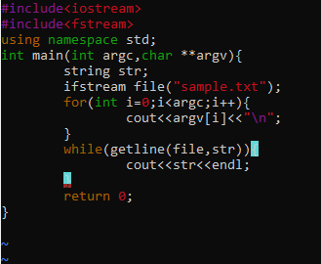

- Extract username, host and domain name from all valid email id’s . (Consider only domain names as .com or .edu as valid domains).

